**Name:** Ahmed Wael Mohamed

**ID:** 6071

**Group:** 2

**Section:** 2

**Problem Code**

%Generate a random sequence of bits (Zeros and Ones)

seq = randi([0 1],1e6,1);

%Counter for BER Array and SNR Array indeces

count = 1;

%Apply noise to the generated sequence of bits

for m = 0:2:30

matrix = awgn(seq,m,'measured');

BER = 0;

%Setting or clearing bits according to addition of noise to sequence

for n = 1:1:1e6

if matrix(n) < 0.5

matrix(n) = 0;

else

matrix(n) = 1;

end

end

%Identify the BER

for n = 1:1:1e6

if seq(n) ~= matrix(n)

BER = BER + 1;

end

end

%Adding the BER to the BER Array

BERMatrix(count) = BER;

%Adding the SNR value to the SNR Array

SNRArray(count) = m;

count = count + 1;

end

%Plotting the logarithmic Graph

semilogy(SNRArray,BERMatrix);

signalPower = sum(seq);

grid on

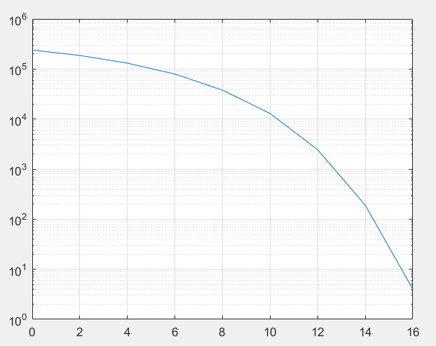

* Transmitted signal power = .
* The meaning of ‘measured’ is the power of the signal before adding noise.
* The system is nearly with no bit errors at value 16 which is the last value.